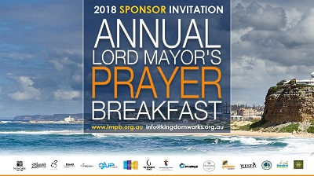

2018 LMPB & SLF SPONSOR REGISTRATION
Please return this information to info@kingdomworks.org.au

I would like to be a FINANCIAL ($1,000) sponsor of the 2018 Annual Lord Mayor’s Prayer Breakfast and Student Leadership Forum.

I would like to be an INKIND sponsor of the 2018 Annual Lord Mayor’s Prayer Breakfast and Student Leadership Forum.

NAME

NAME OF ORGANISATION

ADDRESS

MOBILE

EMAIL

SIGNATURE

DATE

Thank you for being a sponsor of this significant civic event in 2018!

